The Rabbit Listened by Cori Doerrfeld

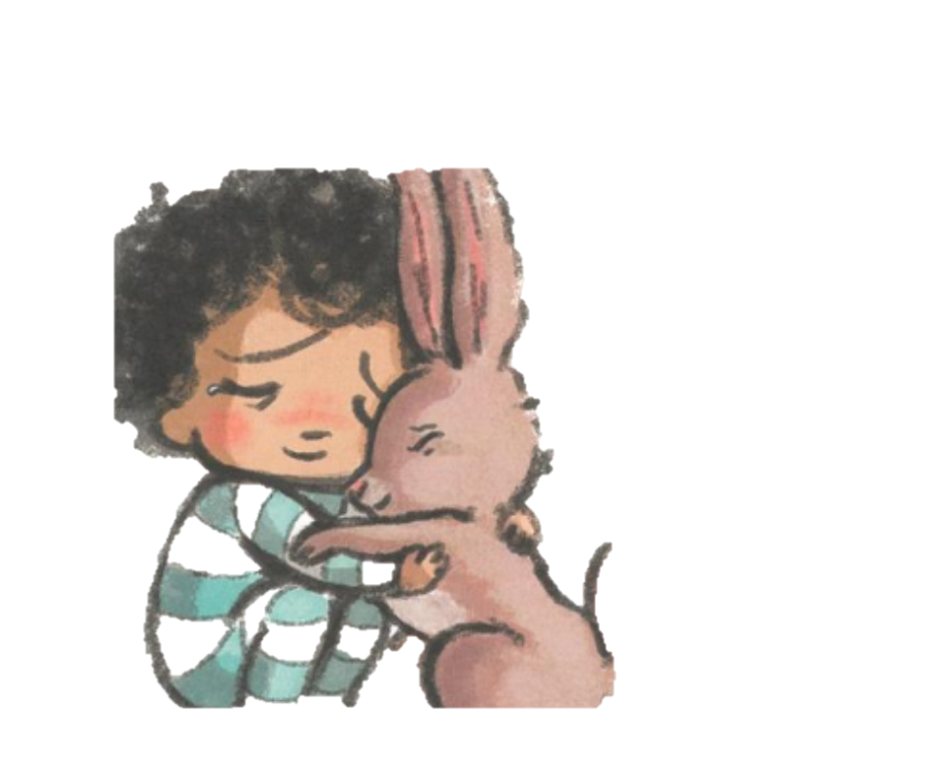

|  |  |
| --- | --- |
| What are the different suggestions the animals give to Taylor? | What did the rabbit do? |
| How can this story apply to mentoring? | What are ways you can be a better listener? |